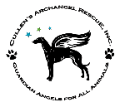
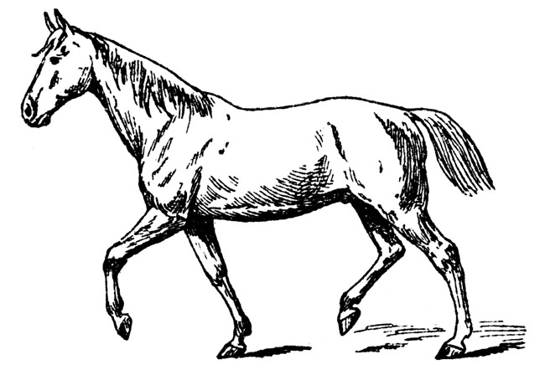
Cullen’s Archangel RescuE, Inc. (CARE)
Equine Adoption Application
P. O. Box 90060, Columbia, SC 29290
President: Tara Haltiwanger | 803.622.9813 | caretoadopt@gmail.com
www.caretoadopt.org

Name _____________________________________________________

Street _____________________________________________________

City/State/Zip _______________________________________________

Home Phone (______) _________________ Mobile Phone (______) _________________

Email address ______________________________________________

Best time & number to call you? __________________________________________________

Occupation ______________________________________ Work Phone (______) _________________

What type of home do you live in? _______________________________ (House, trailer, apartment, duplex, etc.)

Own__ or Rent___ If renting does your landlord allow Equine and is pet deposit paid? Yes ____ No ____

*A letter from your landlord stating you have permission to have this horse live on the premises is required

Are you willing to have one of our representatives visit you in your home/property and boarding facility, if applicable, prior to adoption? Yes___ or No___

Equine Property Location:

If the horse will be kept someplace other than the address listed above, please provide the name of the facility, address, contact person and phone number:

______________________________________________________________________________________________

Name of horse(s) you are interested in: ____________________ Sex(s): ______

Why do you want this horse(s)? ____________________________________________________________________

______________________________________________________________________________________________

How much time per week do you plan on spending with the horse(s)? _______________________________________

If the horse is rideable, how often each week and for how long do you plan on riding?

______________________________________________________________________________________________

If you will be using the horse for riding please list the names and ages of everyone who will be riding: _____________

_____________________________________________________________________________________________

Are there children living in the home (or visit often)? Yes___ or No___ Ages _________________________

If yes, are these children good with animals and have experience around farm animals? Yes ____ No ____

Do you plan to supervise children at all times with the equine you adopt? Yes ____ No ____

Are you familiar with common equine illnesses and how to handle them? Yes___ or No___

Are you prepared to keep the horse(s) for the span of their life, up to 25-30+ years? (Including equine’s that need medical attention or life style changes) Yes _____ No _____

Current Equine Information:

How many horses do you currently have? ____________________________________________________

Are they current on vaccines, dewormings, hoof and teeth care? Yes ____ No ____

Date of last negative Coggins, please list date on ALL horses who will be near the horse(s) you are adopting:

______________________________________________________________________________________________

______________________________________________________________________________________________

Equine Experience:
If you have previously or currently owned horses, please tell us how long you have had them, why you may no longer have the, and if you have given away or sold any horses.

______________________________________________________________________________________________

______________________________________________________________________________________________

______________________________________________________________________________________________

Describe your experience with handling, caring for, riding and/or training horses:
_______________________________________________________________________________________

Who will be feeding the horse and how often?

Are you financially able and willing to follow through on routine and emergency farrier and veterinary visits for hoof trimming, shoeing, dental cleanings, wormings, and other needs as they arise? Yes ____ No ____
Please describe how the horse(s) will be housed and exercised (barn, stall, paddock, size, fencing, etc.):

______________________________________________________________________________________________

______________________________________________________________________________________________

______________________________________________________________________________________________

Required References:

Indicate if you are: ___ currently using this vet or ____ this will be a new vet for you.

Equine Veterinarian/Practice Name: _____________________________________

Phone number ________________________________________________________

Address: __________________________________________________________________________________

Equine Professional Reference’s Name ___________________________Phone Number ________________

Address: ______________________________________________________________________________________

Best time to contact: _____________________

Indicate profession: ___ farrier ____ trainer/riding instructor ___ breeder ___ other _________________

Personal references:

Name: ____________________________________________ Phone Number: _______________________

Relationship: ___________________________ Best time to contact? ________________________________

Name: ____________________________________________ Phone Number: _______________________

Relationship: ___________________________ Best time to contact? ________________________________

Emergency Veterinarian Information:

Equine Veterinarian/Practice Name: ___________________________________ Phone number _________________

Address: __________________________________________________________________________________

* If you do not know who handles emergencies in your city, please research and list them here. Be sure to know in case an emergency ever arises. Most vets will not see their client’s emergencies. We would like to make sure you are prepared. Please keep this information on your refrigerator or close to the phone.

How did you hear about this animal? ________________________________________________

Adoption Agreement:

I understand that adopting a pet is a lifelong commitment and I am willing to take on this commitment for the pet I adopt from Cullen’s Archangel RescuE, Inc. (CARE). I understand that CARE and/or the veterinarians they use have taken care of everything they see medically necessary for this animal at this time. I understand that any medical condition(s) or medical treatment that may be deemed necessary for this pet at a future time will be my financial responsibility alone. I will not hold CARE or its veterinarians responsible for any medical issues that exist after the time of adoption, unless otherwise noted by CARE’s Board of Directors on the bottom of this form. I understand that I may, and am encouraged to, contact CARE should any medical issues arise for guidance and any assistance they may be willing to provide us. I understand that this does not obligate CARE to assist with any expenses incurred after adoption in any way. CARE will gladly provide phone and/or email support for the life of this pet post adoption.

I certify that all the information I have provided in this adoption application is accurate and true. The terms of the application are expressly included in this agreement. I understand that if a reason ever arises that I can no longer keep this animal, I MUST return this animal to CARE only within one week (7 days). CARE will immediately become the sole legal guardian/owner of the adopted pet after it receives written notification from the adopter that he or she can no longer keep this animal. I also understand that I am not allowed to adopt this animal from CARE and give it to anyone else as a gift or for any other reason. Further, if CARE determines in its reasonable discretion that you are no longer able or willing to keep this animal, then you likewise must return this animal to CARE only within one week (7 days).

I am aware I will need to pay an adoption fee via cash or check in the amount of $___________ for this pet after CARE’s Board of Directors has approved my adoption of this pet. I am aware that should I return this pet at a later date, my adoption fee may or may not be returned and that the decision is up to the President of CARE. I understand that CARE is a nonprofit organization with limited funds.

I promise to continue to keep up with routine veterinary exams and medical treatment as necessary. I agree to feed this animal 100% nutritionally complete food, provide an ample supply of fresh & clean water and appropriate shelter at all times throughout his/her life. I agree to keep this pet safely confined in my house and/or a proper species-specific habitat. I will not let this pet run loose outdoors at any time. I agree to provide regular and secure exercise through harness/leash-walking and/or in a completely enclosed and safe area. I will never confine this pet on a rope or chain intended as a tie-out and will never cage/crate this animal excessively (must be in accordance with the law). I agree not to breed this animal at any time. Most importantly, I agree to treat this animal as part of my family.

CARE makes no guarantee against accidents nor do we guarantee compatibility with your current pets.

Last, I certify that I am at least 18 years of age, a legal US citizen, and the person interested in adopting this pet. I agree to include a photocopy of my current driver’s license for verification purposes. I understand that this will be kept confidential and not given out to any other parties. If you falsify any information or neglect to inform us of any information that is pertinent in processing your application, your application will not be approved. If falsification is discovered after adoption, this pet will be removed from your possession immediately.

This agreement is binding upon all parties hereto, their heirs, successors and assigns, and shall be governed in accordance with the laws of the State of South Carolina. Any legal actions or disputes will be resolved in the County of Richland, State of South Carolina, or your residence county at CARE’s sole and unilateral discretion. This is the full and final agreement. There are no other agreements, oral or otherwise. Any subsequent agreements will be entered into in writing. If CARE is required to initiate a legal action to retrieve this animal from your possession, you shall be required to pay for all attorney’s fees. Further, you agree that CARE shall be entitled to immediate injunctive relief, awarding CARE custody of the animal pending resolution of the underlying legal action.

Pets receive all necessary veterinary care, depending upon age and other requirements, prior to adoption. This typically includes an exam, deworming(s), and/or other services required to treat an already existing illness/injury, and neutering the pet. If this pet has not completed vet care for any reason, I agree to also sign and fulfill CARE’s Medical Completion Contract and pay a refundable deposit.

I have read and agree to the terms of CARE’s adoption agreement. Initial here in permanent ink _______ and sign below.

Application Date ______________________ Approval Date ______________________

______________________________________ __________________________________________
Signature of Applicant (must be in ink) Printed Name of Applicant

Interview Date ______________ __________________________________________
CARE Board Member Signature

CARE’s Medical Completion Contract: Is one required? Yes ____ or No ____ Initial if received: _______

CARE sheet specific to this species given to adopter? Yes ____ or No ____ Initial if received: _______

Revised 7/12/13

